
Sreenidhi Institute of Science and Technology
Regulations:
A15
(An Autonomous Institution)
Code No: 5H112 Date:29-Dec-16 (FN)
B. TECH. I-Year I-Semester Examinations, Dec-2016/Jan-2017 (Supplementary)
FUNDAMENTALS OF MATHEMATICS (BT)

Time: 3 Hours Max. Marks:75
Note: a) No additional answer sheets will be provided.
b) All sub-parts of a question must be answered at one place only, otherwise it will not be valued.
c) Assume any missing data.

Part - A
Max.Marks:25

Answer all QUESTIONS

1. Define function .Give two examples of one one and onto functions (3M)

2. Find the equation of the straight line parallel to the line 4x+5y+8=0 and passing through the
point (1,6) (3M)

3. Evaluate 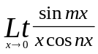 (3M)
4. Find the derivative of 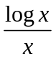 (3M)
5. If z = log(x² +y²) find 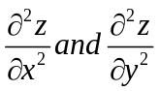 (3M)
6 . Evaluate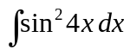 (2M)

7. Evaluate the value of sin15 ⁰ (2M)

8. Dicuss the continuity of f(x)= 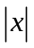 at x=0. (2M)
9. If u= x²+y²+z² then find 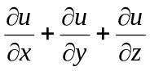 at (1, 2, 3). (2M)
10. Find the derivative of sin(logx) (2M)

Part – B
Max.Marks:50
ANSWER ANY FIVE QUESTIONS. EACH QUESTION CARRIES 10 MARKS.

1(a) Find the square root of 3-4i
(b) Find the value of 2 tan²45⁰ +4 Sin²60⁰ +6 Cot²30⁰+8 Sec²45⁰

2(a) Find the equation of straight line passing through (2,-4) and parallel to the line 6x+8y+15=0
(b) Find the center and radius of the circle 2x²+2y²+6x+8y+5=0

3(a) Evaluate 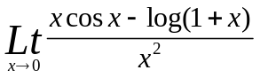
(b) Discuss the continuity of 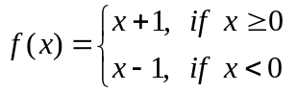 at x = 0.

4(a) Find the derivative of tan2x using the fist principle
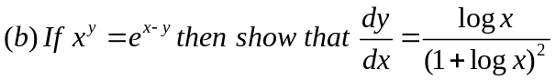

5(a) If y = a sin mx + b cos mx, show that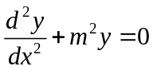
(b)Find the extreme value of 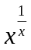

6(a)Evaluate 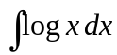
(b)Evaluate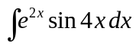

7(a) Show that 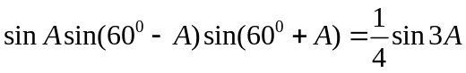
(b) Find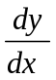 ,if x= a cos³ t, y = a sin³ t

8(a) Evaluate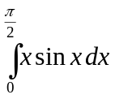
(b)Find the area between the curves y=x² and x²=y

-- 00 -- 00 --

